FILIET: An Information Extraction System

For Filipino Disaster-Related Tweets

Technical Manual

Presented to

the Faculty of the College of Computer Studies

De La Salle University – Manila

In Partial Fulfillment

of the Requirements for the Degree of

Bachelor of Science in Computer Science

by

DELA CRUZ, Kyle Mc Hale B.

GARCIA, John Paul F.

KALAW, Kristine Ma. Dominique F.

LU, Vilson E.

REGALADO, Ralph Vincent

Adviser

April 20, 2015

Table of Contents

1.0 Introduction 1-1

2.0 System Module Class Diagram 2-1

2.1 Models 2-1

2.1.1 Sentence 2-1

2.1.2 Rules 2-2

2.1.3 Extracted Information 2-2

2.2 Crawler Module 2-3

2.3 Information Extraction Engine 2-4

2.3.1 Preprocessor Manager 2-5

2.3.2 Feature Extraction Module 2-8

2.3.3 Classifier Module 2-9

2.3.4 Rule Inductor Module 2-9

2.3.5 OntologyModule 2-10

2.3.6 OntologyRetriever 2-11

2.3.7 Binder 2-11

2.4 Others 2-12

2.4.1 Database 2-12

2.4.2 Reader 2-12

2.4.3 Language Modeller 2-13

2.4.4 XML Parser 2-14

2.5 Entity Relationship Diagram 2-15

3.0 Class Dictionary 3-1

3.1 Models 3-1

3.2 Crawler Module 3-8

3.3 Information Extraction Engine 3-9

3.4 Preprocessing Module 3-10

3.4.1 Preprocessor Manager 3-10

3.4.2 Normalizer 3-10

3.4.3 Tokenizer 3-11

3.4.4 POS Tagger 3-13

3.4.5 NER 3-14

3.5 Feature Extractor Module 3-15

3.6 Classifier Module 3-16

3.7 Rule Induction Module 3-19

3.8 Ontology Module 3-20

3.9 Others 3-29

List of Tables

Table 3‑1. Tweet Class 3-1

Table 3‑2. Sentence Class 3-3

Table 3‑3. Token Class 3-5

Table 3‑4. Rule Class 3-6

Table 3‑5. Grammar Class 3-7

Table 3‑6. ExtractedInformation Class 3-7

Table 3‑7. PostInformationExtracted Class 3-8

Table 3‑8. Crawler Class 3-8

Table 3‑9. InformationEngineExtraction Class 3-9

Table 3‑10. PreprocessorManager Class 3-10

Table 3‑11. NormalizerInterface Class 3-10

Table 3‑12. Normalizer Class 3-11

Table 3‑13. NormApiImpl Class 3-11

Table 3‑14. TokenizerInterface Class 3-11

Table 3‑15. Tokenizer Class 3-12

Table 3‑16. ArkNLPTokenizer Class 3-12

Table 3‑17. OpenNLPTokenizer Class 3-12

Table 3‑18. POSInterface Class 3-13

Table 3‑19. POSTagger Class 3-13

Table 3‑20. POSHashLookupImpl Class 3-13

Table 3‑21. POSLookupImpl Class 3-14

Table 3‑22. NERInterface Class 3-14

Table 3‑23. NamedEntityRecognizer Class 3-14

Table 3‑24. SomidiaHashNERImpl Class 3-15

Table 3‑25. SomidiaNERImpl Class 3-15

Table 3‑26. FeatureExtraction Class 3-15

Table 3‑27. ClassifierInterface Class 3-16

Table 3‑28 ClassifierBuilder Class 3-17

Table 3‑29 Classifier Class 3-17

Table 3‑30 ClassifierImpl Class 3-18

Table 3‑31 MultiClassifierImpl Class 3-18

Table 3‑32 RuleInductor Class 3-19

Table 3‑33 OntologyModule Class 3-20

Table 3‑34. Tweet Class (Ontology) 3-22

Table 3‑35. CallForHelpTweet Class 3-23

Table 3‑36. CasualtiesAndDamageTweet Class 3-24

Table 3‑37. CautionAndAdviceTweet Class 3-24

Table 3‑38. DonationTweet Class 3-25

Table 3‑39 OntologyRetriever Class 3-25

Table 3‑40. DPVPair Class 3-26

Table 3‑41. LabelledDPVPair Class 3-27

Table 3‑42. RetrievedTweet Class 3-27

Table 3‑43. Binder Class 3-28

Table 3‑44. DBFactory Class 3-29

Table 3‑45. DBConnection Class 3-30

Table 3‑46. Reader Class 3-30

Table 3‑47. XmlParser Class 3-30

Table 3‑48. DocumentFrequency Class 3-31

Table 3‑49. WeightScorer Class 3-32

Table 3‑50. NGramModeller Class 3-32

Table 3‑51. Filter Class 3-33

# Introduction

FILIET (Filipino Information Extraction for Twitter) is an information extraction system that makes use of handcrafted rules in order to extract the information from tweets composed in the Filipino language. The system is composed of six modules: the crawler, preprocessor, feature extraction, classification, rule inductor, and ontology module. The crawler module can be run as a standalone feature of the system whereas the rest are integrated. Through the crawler module, tweets are collected and stored in the database which is then exported to a CSV file. The remainder of the FILIET system makes use of the exported CSV file for extraction.

# System Module Class Diagram

## Models

### Sentence

### Rules

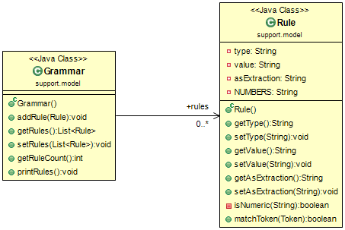

### Extracted Information

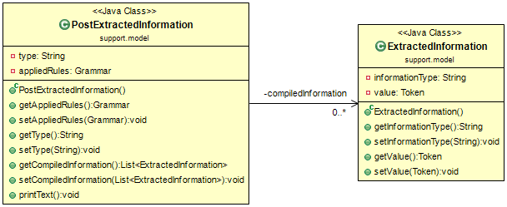

## Crawler Module

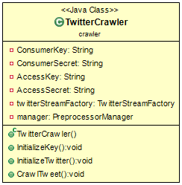

## Information Extraction Engine

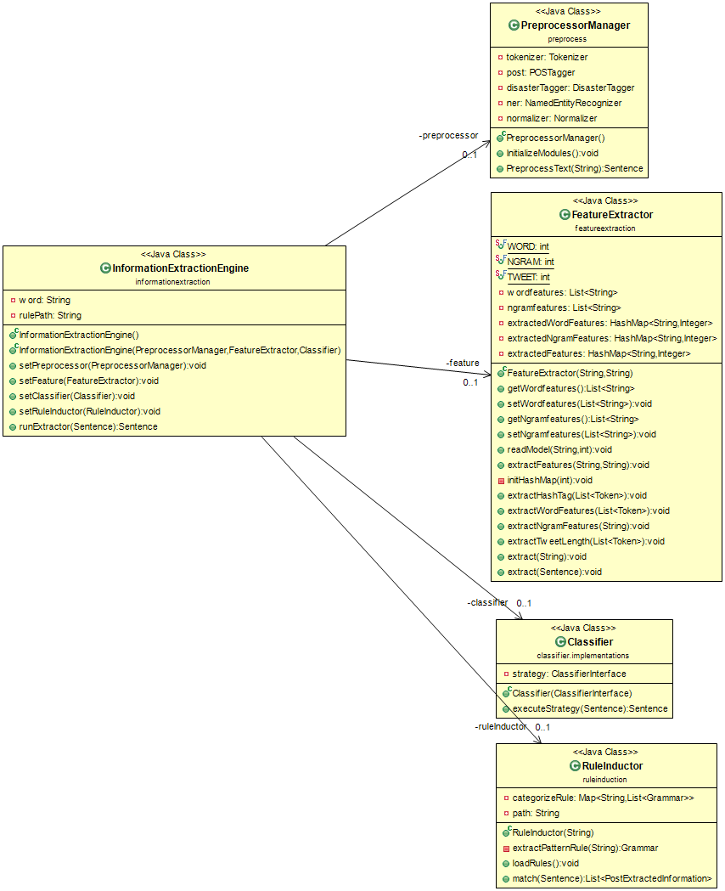

### Preprocessor Manager

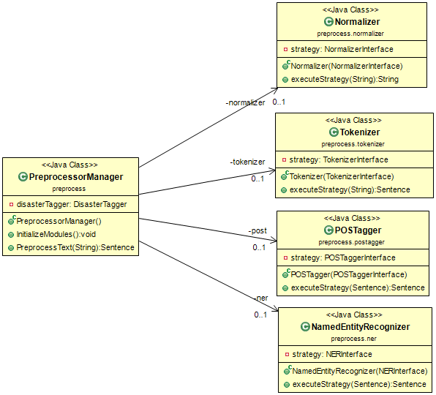

#### Normalizer

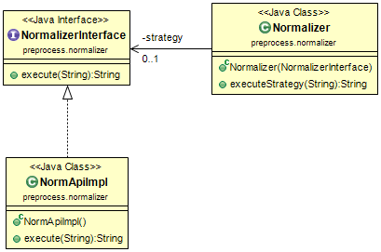

#### Tokenizer

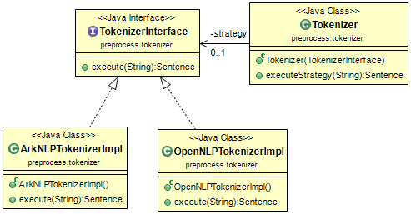

#### POS Tagger

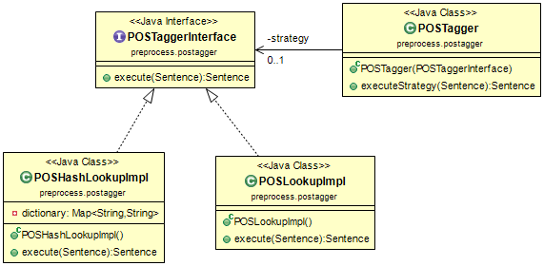

#### NER

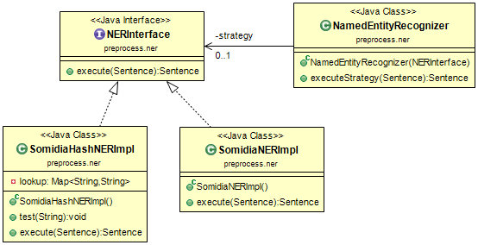

### Feature Extraction Module

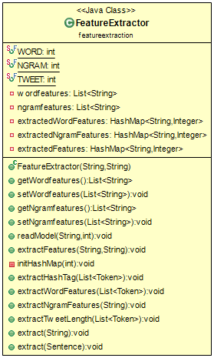

### Classifier Module

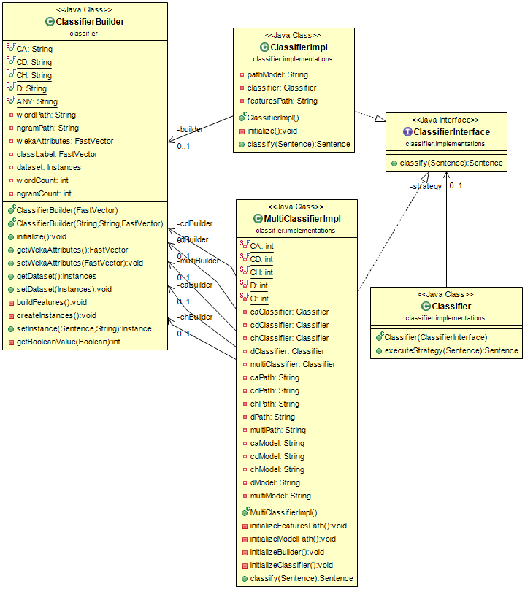

### Rule Inductor Module

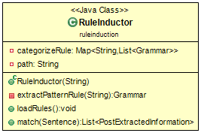

Ontology

### OntologyModule

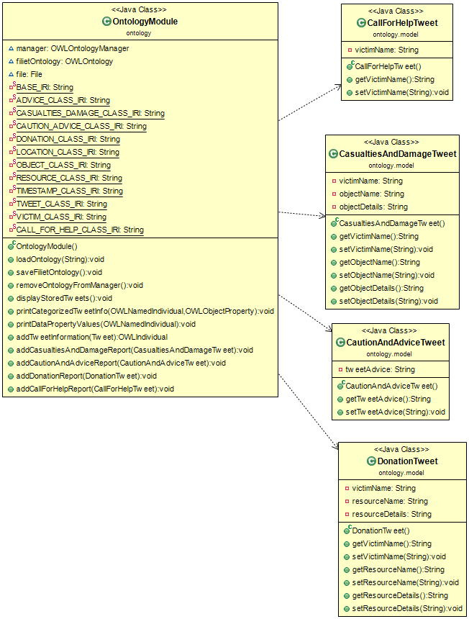

### OntologyRetriever

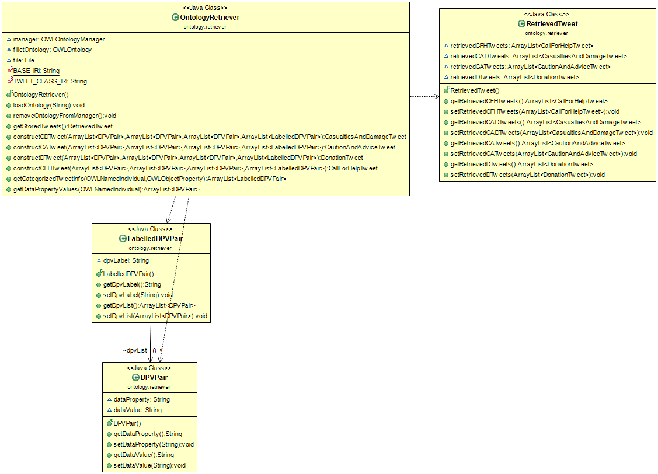

### Binder

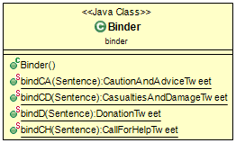

## Others

### Database

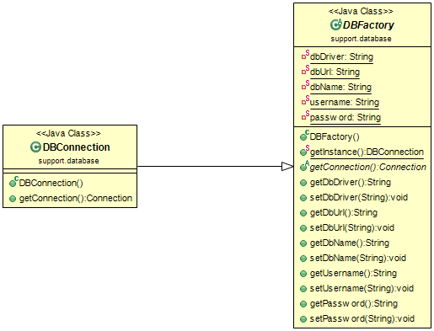

### Reader

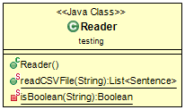

### Language Modeller

#### Document Frequency

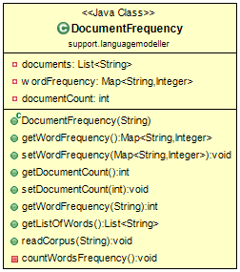

#### WeightScorer

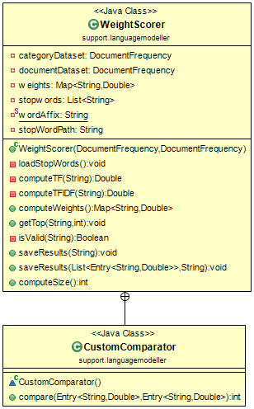

#### N-Gram Modeller

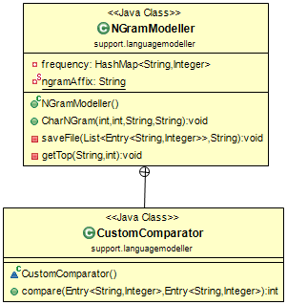

### XML Parser

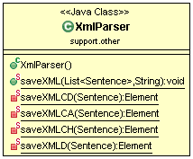

## Entity Relationship Diagram

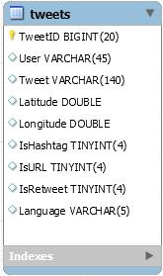

# Class Dictionary

|  |  |
| --- | --- |
| **Module Name** | **File Name** |
| Crawler Module | 1. .\filiet-repo\FILIET\resources\db.properties 2. \filiet-repo\FILIET\resources\twitter.properties |
| Preprocessor Module | 1. \filiet-repo\FILIET\resources\NamedEntityRecognizerDictModel 2. \filiet-repo\FILIET\resources\posDictionary |
| Feature Extraction Module | 1. \filiet-repo\FILIET\resources\model\TFIDF-Scores\mario-ruby\marioruby-word-combined-30.txt |
| Classifier Module | 1. \filiet-repo\FILIET\resources\model\classifier\multiclassifier\mario-marioruby-randomforest-30-model.model 2. \filiet-repo\FILIET\resources\model\classifier\multiclassifier\mario-rf-ca-30.model 3. \filiet-repo\FILIET\resources\model\classifier\multiclassifier\mario-rf-cd-30.model 4. \filiet-repo\FILIET\resources\model\classifier\multiclassifier\mario-rf-ch-30.model 5. \filiet-repo\FILIET\resources\model\classifier\multiclassifier\mario-rf-d-30.model 6. \filiet-repo\FILIET\resources\model\TFIDF-Scores\mario-ruby\marioruby-word-combined-30.txt 7. \filiet-repo\FILIET\resources\model\TFIDF-Scores\mario\archive\mario-word-ca-30.txt 8. \filiet-repo\FILIET\resources\model\TFIDF-Scores\mario\archive\mario-word-cd-30.txt 9. \filiet-repo\FILIET\resources\model\TFIDF-Scores\mario\archive\mario-word-ch-30.txt 10. \filiet-repo\FILIET\resources\model\TFIDF-Scores\mario\archive\mario-word-d-30.txt |
| Rule Inductor | 1. \filiet-repo\FILIET\resources\rules\simple-rules |
| Ontology | 1. \filiet-repo\FILIET\resources\ontology\Ruby_OWL.owl |

## Models

Table 3‑1. Tweet Class

|  |  |  |  |  |
| --- | --- | --- | --- | --- |
| **Description** | The Sentence class is the class that holds all information about the tweet instance | | | |
| **Type** | Class | | | |
| **Attributes** | **Data Type** | **Constraint** | **Description** | |
| TweetID | Long | Private | Stores the ID of the tweet | |
| User | String | Private | Stores the author of the tweet | |
| Tweet | Double | Private | Stores the message (tweet) | |
| Latitude | Double | Private | Stores the latitude where the author posted the tweet (if it is available) | |
| Longitude | Double | Private | Stores the longitude where the author posted the tweet (if it is available) | |
| Retweet | Boolean | Private | Tells if the tweet is a retweet | |
| Hashtag | Boolean | Private | Tells if the tweet contains a hashtag | |
| URL | Boolean | Private | Tells if the tweet contains URL link | |
| Language | String | Private | Stores the language the tweet is written | |
| Category | String | Private | Stores the manually annotated category | |
| Status | Status | Private | Stores other information about the tweet (from Twitter4j library) | |
| **Method Name** | **Description** | **Parameters** | **Returns** | **Constraint** |
| isURL | Tell if the tweet contains URL | Status | Boolean | Public |
| isHashtag | Tell if the tweet contains hashtag | Status | Boolean | Public |
| getTweetID | Return the tweet ID | Void | Long | Public |
| setTweetID | Sets the tweet ID | Long | Void | Public |
| getUser | Returns the tweet’s author | Void | String | Public |
| setUser | Se the tweet’s author | String | Void | Public |
| getTweet | Return the message (tweet) | Void | String | Public |
| setTweet | Sets the message (tweet) | String | Void | Public |
| getLatitude | Get the location (latitude) | Void | Double | Public |
| setLatitude | Set the location (latitude) | Double | Void | Public |
| getLongitude | Get the location (longitude) | Void | Double | Public |
| setLongitude | Set the location (longitude) | Double | Void | Public |
| getRetweet | Return the Retweet’s value | Void | Boolean | Public |
| setRetweet | Set the Retweet value | Boolean | Void | Public |
| getHashtag | Get the Hashtag value | Void | Boolean | Public |
| setHashtag | Set the Hashtag value | Boolean | Void | Public |
| getURL | Get the URL value | Void | Boolean | Public |
| setURL | Set the URL value | Void | Boolean | Public |
| getLanguage | Get the language value | Void | String | Public |
| setLanguage | Set the language value | String | Void | Public |
| getCategory | Get the Category value | Void | String | Public |
| setCategory | Set the Category value | String | Void | Public |
| getStatus | Get the Status object (Twitter 4j) | Void | Status | Public |
| setStatus | Set the Status object (Twitter 4j) | Status | Void | Public |
| StoreTweet | Store the tweet in the database | Void | Void | Public |

Table 3‑2. Sentence Class

|  |  |  |  |  |
| --- | --- | --- | --- | --- |
| **Description** | The Sentence class is the class that holds all information about the tweet | | | |
| **Type** | Class | | | |
| **Attributes** | **Data Type** | **Constraint** | **Description** | |
| extractedWordFeatures | HashMap<String,Integer> | Private | Contains the extracted word features and its frequency. | |
| extractedNgramFeatures | HashMap<String, Integer | Private | Contains the extracted n-gram features and its frequency. | |
| extractedFeatures | HashMap<String,Integer | Private | Contains other features and its values (Length) | |
| appliedRules | List<Grammar> | Private | Contains the list of extraction rules that was applied to the tweet. | |
| tweets | Tweet | Private | Contains information about the tweet. | |
| sentence | ArrayList<Token> | Private | Contains the tokenized tweet. | |
| category | String | Private | The category labelled by the classifier. | |
| extractedInformation | List<PostExtractedInformation> | Private | Contains the list of extracted information. | |
| **Method Name** | **Description** | **Parameters** | **Returns** | **Constraint** |
| getTweets | Gets the Tweet information. | Void | Tweet | Public |
| setTweets | Set the Tweet information. | Tweet | Void | Public |
| getExtractedWordFeatures | Get the extracted word features | Void | HashMap<String,Integer> | Public |
| setExtractedWordFeatures | Set the extracted word features | HashMap<String,Integer> | Void | Public |
| getExtractedNgramFeatures | Get the extracted n-gram features | Void | HashMap<String,Integer> | Public |
| setExtractedNgramFeatures | Set the extracted n-gram features | HashMap<String,Integer> | Void | Public |
| getSentence | Get the ArrayList of Tokens (tokenized Tweet) | Void | ArrayList<Token> | Public |
| setSentence | Set the ArrayList of Tokens (tokenized Tweet) | ArrayList<Token> | Void | Public |
| addToken | Add a token to the ArrayList | Token | Void | Public |
| getLength | Get the length of the token | Void | Int | Public |
| getToken | Get the specific token with the same word | String | Token | Public |
| getToken | Get the specific token using index | Int | Token | Public |
| getExtractedInformation | Get the extracted information | Void | List<PostExtractedInformation> | Public |
| setExtractedInformation | Set the extracted information | List<PostExtractedInformation> | Void | Public |
| getCategory | Get the category labelled by the classifier | Void | String | Public |
| setCategory | Sets the category labelled by the classifier | String | Void | Public |
| getRawTweet | Gets the unprocessed tweet | Void | Tweet | Public |

Table 3‑3. Token Class

|  |  |  |  |  |
| --- | --- | --- | --- | --- |
| **Description** | The Token class holds information about a single word. | | | |
| **Type** | Class | | | |
| **Attributes** | **Data Type** | **Constraint** | **Description** | |
| Word | String | Private | A tokenized word | |
| POSTag | String | Private | The Part-of-Speech tag of the word | |
| NERTag | String | Private | The entity of the word | |
| **Method Name** | **Description** | **Parameters** | **Returns** | **Constraint** |
| getWord | Returns the tokenized word | Void | String | Public |
| setWord | Sets the tokenized word | String | Void | Public |
| getPOSTag | Returns the POS Tag of the word | Void | String | Public |
| setPOSTag | Sets the POS Tag of the word | String | Void | Public |
| getNERTag | Returns the NER Tag of the word | Void | String | Public |
| setNERTag | Sets the NER Tag of the Word | String | Void | Public |
| PrintToken | Prints the word and its POS Tags and NER Tags | Void | Void | Public |

|  |  |  |  |  |
| --- | --- | --- | --- | --- |
| **Description** | The Token class holds information about a single word. | | | |
| **Type** | Class | | | |
| **Attributes** | **Data Type** | **Constraint** | **Description** | |
| Word | String | Private | A tokenized word | |
| POSTag | String | Private | The Part-of-Speech tag of the word | |
| NERTag | String | Private | The entity of the word | |
| **Method Name** | **Description** | **Parameters** | **Returns** | **Constraint** |
| getWord | Returns the tokenized word | Void | String | Public |
| setWord | Sets the tokenized word | String | Void | Public |
| getPOSTag | Returns the POS Tag of the word | Void | String | Public |
| setPOSTag | Sets the POS Tag of the word | String | Void | Public |
| getNERTag | Returns the NER Tag of the word | Void | String | Public |
| setNERTag | Sets the NER Tag of the Word | String | Void | Public |
| PrintToken | Prints the word and its POS Tags and NER Tags | Void | Void | Public |

Table 3‑4. Rule Class

|  |  |  |  |  |
| --- | --- | --- | --- | --- |
| **Description** | The Rule class represents a token of the extraction rules. | | | |
| **Type** | Class | | | |
| **Attributes** | **Data Type** | **Constraint** | **Description** | |
| type | String | Private | Tells what kind of extraction to match (POS, NER, or String) | |
| value | String | Private | Tells the value that must be matched | |
| asExtraction | String | Private | Tells the the type of information that will be extracted | |
| **Sample Rule** | <ner (type): LOCATION (value)>[as]LOCATION (asExtraction) | | | |
| **Method Name** | **Description** | **Parameters** | **Returns** | **Constraint** |
| getType | Return the type value | Void | String | Public |
| setType | Set the type attribute | String | Void | Public |
| getValue | Return the value value | Void | String | Public |
| setValue | Set the value attribute | String | Void | Public |
| getAsExtraction | Return the asExtraction value | Void | String | Public |
| setAsExtraction | Set the asExtraction attribute | String | Void | Public |
| match | Checks if the token matches the rule. | Token | Boolean | Public |

Table 3‑5. Grammar Class

|  |  |  |  |  |
| --- | --- | --- | --- | --- |
| **Description** | The Grammar class represents an extraction rules. | | | |
| **Type** | Class | | | |
| **Attributes** | **Data Type** | **Constraint** | **Description** | |
| rules | List<Rules> | Private | Contains the list of Rule tokens | |
| **Method Name** | **Description** | **Parameters** | **Returns** | **Constraint** |
| addRule | Add a Rule to the list | Rule | Void | Public |
| getRules | Get the extraction rule | Void | List<Rule> | Public |
| setRules | Set the extraction rule | List<Rule> | Void | Public |
| getRuleCount | Get the number of Rule tokens | Void | Int | Public |
| printRules | Prints the extraction rules | Void | Void | Public |

Table 3‑6. ExtractedInformation Class

|  |  |  |  |  |
| --- | --- | --- | --- | --- |
| **Description** | The ExtractedInformation Class represents a token of the extracted information. | | | |
| **Type** | Class | | | |
| **Attributes** | **Data Type** | **Constraint** | **Description** | |
| informationType | String | Private | Tells the type of information the token is. | |
| value | Token | Private | The token that was extracted | |
| **Method Name** | **Description** | **Parameters** | **Returns** | **Constraint** |
| getInformationType | Return the informationType value | Void | String | Public |
| setInformationType | Set the informationType attribute | String | Void | Public |
| getValue | Return the value value | Void | Token | Public |
| setValue | Set the value attribute | Token | Void | Public |

Table 3‑7. PostInformationExtracted Class

|  |  |  |  |  |
| --- | --- | --- | --- | --- |
| **Description** | The PostInformationExtracted Class represents the extracted information | | | |
| **Type** | Class | | | |
| **Attributes** | **Data Type** | **Constraint** | **Description** | |
| type | String | Private | Stores the type of information | |
| compiledInformation | List<ExtractedInformation> | Private | Stores the extracted information | |
| appliedRules | Grammar | Private | Stores the rules that was used to extract the information | |
| **Method Name** | **Description** | **Parameters** | **Returns** | **Constraint** |
| getAppliedRules | Returns the applied rules | Void | Grammar | Private |
| setAppliedRules | Set the applied rules | Grammar | Void | Private |
| getType | Get the type | Void | String | Private |
| setType | Set the type | String | Void | Private |
| getCompiledInformation | Get the compiledInformation | Void | List<ExtractedInformation> | Private |
| setCompiledInformation | Set the compiledInformation | List<ExtractedInformation> | Void | Private |
| printText | Prints the extracted information | Void | Void | Private |

## Crawler Module

Table 3‑8. Crawler Class

|  |  |  |  |  |
| --- | --- | --- | --- | --- |
| **Description** | The Crawler Class collects the Tweets from Twitter. | | | |
| **Type** | Class | | | |
| **Attributes** | **Data Type** | **Constraint** | **Description** | |
| ConsumerKey | String | Private | This is used to allow the API to make calls to Twitter. | |
| ConsumerSecret | String | Private | This is used to allow the API to make calls to Twitter. | |
| AccessKey | String | Private | This is the oAuth token to represent the user. | |
| AccessSecret | String | Private | This is the oAuth token to represent the user. | |
| twitterStreamFactory | TwitterStreamFactory (Twitter4j) | Private | Generates the Twitter streams | |
| **Method Name** | **Description** | **Parameters** | **Returns** | **Constraint** |
| InitializeKey | Initializes the ConsumerKey, Consumer Secret, AccessKey, and AccessSecret | Void | Void | Private |
| InitializeTwitter | Initializes the TwitterStreamFactory | Void | Void | Private |
| CrawlTweet | Listens to incoming tweets and store them in the database | Void | Void | Public |

## Information Extraction Engine

Table 3‑9. InformationEngineExtraction Class

|  |  |  |  |  |
| --- | --- | --- | --- | --- |
| **Description** | The InformationEngineExtraction class integrates the preprocessing module, feature extraction module, classifier module, and the rule inductor module. | | | |
| **Type** | Class | | | |
| **Attributes** | **Data Type** | **Constraint** | **Description** | |
| word | String | Private | Path to the word features file | |
| rulePath | String | Private | Path to the rule list file | |
| preprocessor | PreprocessorManager | Private | Handles all the preprocessing of the tweets | |
| feature | FeatureExtractor | Private | Extracts the features in the tweet | |
| classifier | Classifier | Private | Classifies the tweet into the category | |
| ruleInductor | RuleInductor | Private | Applies extraction rules to get the relevant information | |
| **Method Name** | **Description** | **Parameters** | **Returns** | **Constraint** |
| runExtractor | Runs all the extraction modules. Returns a processed tweet. | String | Sentence | Public |
| setPreprocessor | Sets the PreprocessorManager | PreprocessorManager | Void | Public |
| setFeature | Sets the FeatureExtraction | FeatureExtractor | Void | Public |
| setClassifier | Sets the Classifier | Classifier | Void | Public |
| setRuleInductor | Sets the RuleInductor | RuleInductor | Void | Public |

## Preprocessing Module

### Preprocessor Manager

Table 3‑10. PreprocessorManager Class

|  |  |  |  |  |
| --- | --- | --- | --- | --- |
| **Description** | The Preprocessor Manager handles all the preprocessing module | | | |
| **Type** | Class | | | |
| **Attributes** | **Data Type** | **Constraint** | **Description** | |
| normalizer | Normalizer | Private | Normalizer module | |
| tokenizer | Tokenizer | Private | Tokenizer module | |
| post | POSTagger | Private | POS Tagger module | |
| ner | NamedEntityRecognizer | Private | NER module | |
| **Method Name** | **Description** | **Parameters** | **Returns** | **Constraint** |
| InitializeModule | Initializes all the preprocessing modules | Void | Void | Private |
| PreprocessText | The raw tweet will be processed through the preprocessing modules | String | Sentence | Public |

### Normalizer

Table 3‑11. NormalizerInterface Class

|  |  |  |  |  |
| --- | --- | --- | --- | --- |
| **Description** | The NormalizerInterfce class is an interface that tells to implement the executeStrategy() method. | | | |
| **Type** | Interface | | | |
| **Attributes** | **Data Type** | **Constraint** | **Description** | |
|  |  |  |  | |
| **Method Name** | **Description** | **Parameters** | **Returns** | **Constraint** |
| executeStrategy | Executes the normalizer | String | Sentence | Public |

Table 3‑12. Normalizer Class

|  |  |  |  |  |
| --- | --- | --- | --- | --- |
| **Description** | The Normalizer class is the class that implements the NormalizerInterface. | | | |
| **Type** | Class | | | |
| **Attributes** | **Data Type** | **Constraint** | **Description** | |
| strategy | NormalizerInterface | Private | Stores the implementation that will be used by the executeStrategy method | |
| **Method Name** | **Description** | **Parameters** | **Returns** | **Constraint** |
| executeStrategy | Executes the normalizer. The Normalizer returns the tweet that has been normalized | String | Sentence | Public |

Table 3‑13. NormApiImpl Class

|  |  |  |  |  |
| --- | --- | --- | --- | --- |
| **Description** | The NormApiImpl class implements the Tokenizer using the NormAPI | | | |
| **Type** | Class | | | |
| **Attributes** | **Data Type** | **Constraint** | **Description** | |
|  |  |  |  | |
| **Method Name** | **Description** | **Parameters** | **Returns** | **Constraint** |
| executeStrategy | Executes the normalizes that uses Norm API | String | Sentence | Public |

### Tokenizer

Table 3‑14. TokenizerInterface Class

|  |  |  |  |  |
| --- | --- | --- | --- | --- |
| **Description** | The TokenizerInterface class is an interface that tells to implement the executeStrategy() method. | | | |
| **Type** | Interface | | | |
| **Attributes** | **Data Type** | **Constraint** | **Description** | |
|  |  |  |  | |
| **Method Name** | **Description** | **Parameters** | **Returns** | **Constraint** |
| executeStrategy | Executes the tokenizer | String | Sentence | Public |

Table 3‑15. Tokenizer Class

|  |  |  |  |  |
| --- | --- | --- | --- | --- |
| **Description** | The Tokenizer class is the class that implements the TokenizerInterface. | | | |
| **Type** | Class | | | |
| **Attributes** | **Data Type** | **Constraint** | **Description** | |
| strategy | TokenizerInterface | Private | Stores the implementation that will be used by the executeStrategy method | |
| **Method Name** | **Description** | **Parameters** | **Returns** | **Constraint** |
| executeStrategy | Executes the tokenizer. Returns a Sentence object that has the tokenized tweet. | String | Sentence | Public |

Table 3‑16. ArkNLPTokenizer Class

|  |  |  |  |  |
| --- | --- | --- | --- | --- |
| **Description** | The ArkNLPTokenizer class implements the Tokenizer using the ArkNLP library. | | | |
| **Type** | Class | | | |
| **Attributes** | **Data Type** | **Constraint** | **Description** | |
|  |  |  |  | |
| **Method Name** | **Description** | **Parameters** | **Returns** | **Constraint** |
| executeStrategy | Executes the tokenizer that uses the ArkNLP Tokenizer | String | Sentence | Public |

Table 3‑17. OpenNLPTokenizer Class

|  |  |  |  |  |
| --- | --- | --- | --- | --- |
| **Description** | The OpenNLPTokenizer class implements the Tokenizer using the OpenNLP library. | | | |
| **Type** | Class | | | |
| **Attributes** | **Data Type** | **Constraint** | **Description** | |
|  |  |  |  | |
| **Method Name** | **Description** | **Parameters** | **Returns** | **Constraint** |
| executeStrategy | Executes the tokenizer that uses OpenNLP Tokenizer | String | Sentence | Public |

### POS Tagger

Table 3‑18. POSInterface Class

|  |  |  |  |  |
| --- | --- | --- | --- | --- |
| **Description** | The POSInterface class is an interface that tells to implement the executeStrategy() method. | | | |
| **Type** | Interface | | | |
| **Attributes** | **Data Type** | **Constraint** | **Description** | |
|  |  |  |  | |
| **Method Name** | **Description** | **Parameters** | **Returns** | **Constraint** |
| executeStrategy | Executes the tokenizer | String | Sentence | Public |

Table 3‑19. POSTagger Class

|  |  |  |  |  |
| --- | --- | --- | --- | --- |
| **Description** | The POSTagger class is the class that implements the POSInterface. | | | |
| **Type** | Class | | | |
| **Attributes** | **Data Type** | **Constraint** | **Description** | |
| strategy | POSInterface | Public | Stors the implementation that the executeStrategy will use | |
| **Method Name** | **Description** | **Parameters** | **Returns** | **Constraint** |
| executeStrategy | Executes the POS Tagger. Each token now may contain a POS tag. | String | Sentence | Public |

Table 3‑20. POSHashLookupImpl Class

|  |  |  |  |  |
| --- | --- | --- | --- | --- |
| **Description** | The POSHashLookupImpl class implements POS lookup that uses a HashMap | | | |
| **Type** | Class | | | |
| **Attributes** | **Data Type** | **Constraint** | **Description** | |
| dictionary | HashMap<String,Integer> | Private | Stores the list of words and its corresponding part-of-speech | |
| **Method Name** | **Description** | **Parameters** | **Returns** | **Constraint** |
| executeStrategy | Executes the POS Tagger using the POS Hash Lookup implementation | Sentence | Sentence | Public |

Table 3‑21. POSLookupImpl Class

|  |  |  |  |  |
| --- | --- | --- | --- | --- |
| **Description** | The POSLookupImpl class implements POS lookup. | | | |
| **Type** | Class | | | |
| **Attributes** | **Data Type** | **Constraint** | **Description** | |
|  |  |  |  | |
| **Method Name** | **Description** | **Parameters** | **Returns** | **Constraint** |
| executeStrategy | Executes the POS Tagger using POS Lookup Implementation | Sentence | Sentence | Public |

### NER

Table 3‑22. NERInterface Class

|  |  |  |  |  |
| --- | --- | --- | --- | --- |
| **Description** | The NERInterface class is an interface that tells to implement the executeStrategy() method. | | | |
| **Type** | Interface | | | |
| **Attributes** | **Data Type** | **Constraint** | **Description** | |
|  |  |  |  | |
| **Method Name** | **Description** | **Parameters** | **Returns** | **Constraint** |
| executeStrategy | Executes the NER Tagger. Each token now may contain a NER tag. | Sentence | Sentence | Public |

Table 3‑23. NamedEntityRecognizer Class

|  |  |  |  |  |
| --- | --- | --- | --- | --- |
| **Description** | The NamedEntityRecognizer class is the class that implements the NERInterface. | | | |
| **Type** | Class | | | |
| **Attributes** | **Data Type** | **Constraint** | **Description** | |
| strategy | NERInterface | Public | Stors the implementation that the executeStrategy will use | |
| **Method Name** | **Description** | **Parameters** | **Returns** | **Constraint** |
| executeStrategy | Executes the POS Tagger. Each token now may contain a POS tag. | Sentence | Sentence | Public |

Table 3‑24. SomidiaHashNERImpl Class

|  |  |  |  |  |
| --- | --- | --- | --- | --- |
| **Description** | The SomidiaHashNERImpl class implements NER lookup that uses a HashMap | | | |
| **Type** | Class | | | |
| **Attributes** | **Data Type** | **Constraint** | **Description** | |
| lookup | HashMap<String,Integer> | Private | Stores the list of words and its corresponding entities | |
| **Method Name** | **Description** | **Parameters** | **Returns** | **Constraint** |
| executeStrategy | Executes the NER Tagger that uses SOMIDIA Hash Lookup Implementation. | Sentence | Sentence | Public |

Table 3‑25. SomidiaNERImpl Class

|  |  |  |  |  |
| --- | --- | --- | --- | --- |
| **Description** | The SomidiaHashNERImpl class implements NER lookup. | | | |
| **Type** | Class | | | |
| **Attributes** | **Data Type** | **Constraint** | **Description** | |
|  |  |  |  | |
| **Method Name** | **Description** | **Parameters** | **Returns** | **Constraint** |
| executeStrategy | Executes the NER Tagger that uses SOMIDIA Lookup Implementation | Sentence | Sentence | Public |

## Feature Extractor Module

Table 3‑26. FeatureExtraction Class

|  |  |  |  |  |
| --- | --- | --- | --- | --- |
| **Description** | The FeatureExtraction Class handles the feature extraction module. | | | |
| **Type** | Class | | | |
| **Attributes** | **Data Type** | **Constraint** | **Description** | |
| wordfeatures | List<String> | Private | For CSV headers (word features) | |
| ngramfeatures | List<String> | Private | For CSV headers (n-gram features) | |
| extractedWordfeatures | HashMap<String,Integer> | Private | Stores the extracted word features | |
| extractedNgramFeatures | HashMap<String,Integer> | Private | Stores the extracted n-gram features | |
| extractedFeatures | HashMap<String,Integer> | Private | Stores the extracted other (tweet length) features | |
| **Method Name** | **Description** | **Parameters** | **Returns** | **Constraint** |
| getWordFeatures | Return the wordfeatures | Void | List<String> - word features | Public |
| setWordFeatures | Set the wordfeatures | List<String> - word features | Void | Public |
| getNgramFeatures | Return the ngramfeatures | Void | List<String> - ngram features | Public |
| setNgramFeatures | Set the ngramfeatures | List<String> - ngram features | Void | Public |
| readModel | Reads the text file that contained the features to be used | String – path to the features, type – tells if it’s a word features list or n-gram feature list | Void | Public |
| extractWordFeatures | Extract the word features from a tokenized text | List<Token> - tokenized | Void | Public |
| extractNgramFeatures | Extracts the n-gram features from a text | String - untokenized | Void | Public |
| extractTweetLength | Count the length of the tweet | List<Token> - tokenized | Void | Public |
| extract | Extracts the unprocessed instance (used for batch processing) | String | Void | Public |
| extract | Extracts the feature of a processed instance | Sentence | Sentence – feature extracted | Public |
| extractFeatures | Extracts the features of a corpus and save the result into a CSV | String – path, String – save | Void | Public |

## Classifier Module

Table 3‑27. ClassifierInterface Class

|  |  |  |  |  |
| --- | --- | --- | --- | --- |
| **Description** | The ClassifierInterface class is an interface that tells to implement the classify() method. | | | |
| **Type** | Interface | | | |
| **Attributes** | **Data Type** | **Constraint** | **Description** | |
|  |  |  |  | |
| **Method Name** | **Description** | **Parameters** | **Returns** | **Constraint** |
| classify | Executes the classifier | Sentence | Sentence | Public |

Table 3‑28 ClassifierBuilder Class

|  |  |  |  |  |
| --- | --- | --- | --- | --- |
| **Description** | The ClassifierBuilder Class creates an Instance class that will be used to classify. It sets the values from the feature extraction to the Instance class. | | | |
| **Type** | Class | | | |
| **Method Name** | **Description** | **Parameters** | **Returns** | **Constraint** |
| Initialize | Initialize the models that will be used for the classification | Void | Void | Public |
| getWekaAttributes | Get the list of attributes | Void | FastVector<Weka> | Public |
| setWekaAttributes | Set the list of attributes | FastVector<Weka> | Void | Public |
| getDataset | Get the created Instances class | Void | Instances | Public |
| setDataset | Set an Instances class | Instances | Void | Public |
| buildFeatures | Sets the attributes that will be used for classification | Void | Void | Private |
| createInstance | Creates the Instances class | Void | Void | Private |
| setInstance | Set the values for the Instance object | Sentence, String | Void | Public |
| getBooleanValue | Returns 1 if true, else 0. | Boolean | Int | Private |

Table 3‑29 Classifier Class

|  |  |  |  |  |
| --- | --- | --- | --- | --- |
| **Description** | The Classifier Class implements the ClassifierInterface. | | | |
| **Type** | Class | | | |
| **Attributes** | **Data Type** | **Constraint** | **Description** | |
| strategy | ClassifierInterface | Private | Stores the implementation that will be used by the executeStrategy method | |
| **Method Name** | **Description** | **Parameters** | **Returns** | **Constraint** |
| classify | Executes the classify method. The Classifier sets the Category field | Sentence | Sentence | Public |

Table 3‑30 ClassifierImpl Class

|  |  |  |  |  |
| --- | --- | --- | --- | --- |
| **Description** | The ClassifierImpl Class is a classifier that uses a single classifier. | | | |
| **Attributes** | **Data Type** | **Constraint** | **Description** | |
| pathModel | String | Private | Path to the classifier model | |
| classifier | Classifier (Weka) | Private | Classifier that classifies all categories | |
| featuresPath | String | Private | Path to the features | |
| Builder | ClassifierBuilder | Private | Creates the instance for the classifier | |
| **Method Name** | **Description** | **Parameters** | **Returns** | **Constraint** |
| Initialize | Initializes the Classifier | Void | Void | Private |
| executeStrategy | Executes the classify method that uses a single classifier implementation. | Sentence | Sentence | Public |

Table 3‑31 MultiClassifierImpl Class

|  |  |  |  |  |
| --- | --- | --- | --- | --- |
| **Description** | The MultiClassifierImpl Class is a classifier that implements a multiple classifier. The classifier is consist of 5 classifiers, 4 binary classifier for each category, and 1 single classifier. | | | |
| **Type** | Class | | | |
| **Attributes** | **Data Type** | **Constraint** | **Description** | |
| caClassifier | Classifier (Weka) | Private | Classifier that classifies CA and O | |
| cdClassifier | Classifier (Weka) | Private | Classifier that classifies CD and O | |
| chClassifier | Classifier (Weka) | Private | Classifier that classifies CH and O | |
| dClassifer | Classifier (Weka) | Private | Classifier that classifies D and O | |
| multiClassifier | Classifier (Weka) | Private | Classifier that classifies all categories | |
| caPath | String | Private | Path to the CA features | |
| cdPath | String | Private | Path to the CD features | |
| chPath | String | Private | Path to the CH features | |
| dPath | String | Private | Path to the D features | |
| multiPath | String | Private | Path to the combined features | |
| caModel | String | Private | Path to the CA model | |
| cdModel | String | Private | Path to the CD model | |
| chModel | String | Private | Path to the CH model | |
| dModel | String | Private | Path to the D model | |
| multiModel | String | Private | Path to the combined model | |
| caBuilder | ClassifierBuilder | Private | Creates the instance for the caClassifier | |
| cdBuilder | ClassifierBuilder | Private | Creates the instance for the cdClassifier | |
| chBuilder | ClassifierBuilder | Private | Creates the instance for the chClassifier | |
| dBuilder | ClassifierBuilder | Private | Creates the instance for the dClassifier | |
| multiBuilder | ClassifierBuilder | Private | Creates the instance for the multiClassifier | |
| **Method Name** | **Description** | **Parameters** | **Returns** | **Constraint** |
| executeStrategy | Executes the classify method that uses the multiple classifier implementation. | Sentence | Sentence | Public |
| initializeFeaturesPath | Sets the location of the features that will be used | Void | Void | Private |
| initializeModelPath | Sets the location of the models that will be used | Void | Void | Private |
| initializeBuilder | Initializes the ClassifierBuilder class | Void | Void | Private |
| initializeClassifier | Initializes the Classifiers. | Void | Void | Private |

## Rule Induction Module

Table 3‑32 RuleInductor Class

|  |  |  |  |  |
| --- | --- | --- | --- | --- |
| **Description** | The RuleInductor Class extracts the information from the tweets by matching the rules. | | | |
| **Type** | Class | | | |
| **Attributes** | **Data Type** | **Constraint** | **Description** | |
| categorizeRule | Map<String,List<Grammar>> | Private | Contains the list of rules for each category | |
| path | String | Private | Path to the rules | |
| **Method Name** | **Description** | **Parameters** | **Returns** | **Constraint** |
| loadRules | Loads the rules from the text files | Void | Void | Public |
| extractPatternRules | Parse the rules from the text files | String | Void | Private |
| match | Extracts the information by matching the rules | Sentence | List<PostExtractedInformation> | Public |

## Ontology Module

Table 3‑33 OntologyModule Class

|  |  |  |  |  |
| --- | --- | --- | --- | --- |
| **Description** | The OntologyModule class is responsible for adding new instances into the ontology. | | | |
| **Attributes** | **Data Type** | **Constraint** | **Description** | |
| manager | OwlOntologyManager | Default | The ontology uses a an OWLManager variable to facilitate the maniuplation of the ontology file. | |
| filietOntology | OwlOntology | Default | This is the variable that contains the actual OWL file of the ontology. | |
| File | File | Default | This is just a variable for containging the OWL file that will be manipulated in the system. | |
| BASE_IRI | String | Private | This is a string that contains the Internationalized Resource Identifier of the actual ontology used by the system. | |
| ADVICE_CLASS_IRI | String | Private | This is a string that contains the Internationalized Resource Identifier of the Advice class in the actual ontology used by the system. | |
| CASUALTIES_DAMAGE_CLASS_IRI | String | Private | This is a string that contains the Internationalized Resource Identifier of the Casualties and Damage class in the actual ontology used by the system. | |
| CAUTION_ADVICE_CLASS_IRI | String | Private | This is a string that contains the Internationalized Resource Identifier of the Caurtion and Advice class in the actual ontology used by the system. | |
| DONATION_CLASS_IRI | String | Private | This is a string that contains the Internationalized Resource Identifier of the Donation class in the actual ontology used by the system. | |
| LOCATION_CLASS_IRI | String | Private | This is a string that contains the Internationalized Resource Identifier of the Location class in the actual ontology used by the system. | |
| OBJECT_CLASS_IRI | String | Private | This is a string that contains the Internationalized Resource Identifier of the Object class in the actual ontology used by the system. | |
| TIMESTAMP_CLASS_IRI | String | Private | This is a string that contains the Internationalized Resource Identifier of the Timestamp class in the actual ontology used by the system. | |
| TWEET_CLASS_IRI | String | Private | This is a string that contains the Internationalized Resource Identifier of the Tweet class in the actual ontology used by the system. | |
| VICTIM_CLASS_IRI | String | Private | This is a string that contains the Internationalized Resource Identifier of the Victim class in the actual ontology used by the system. | |
| CALL_FOR_HELP_CLASS_IRI | String | Private | This is a string that contains the Internationalized Resource Identifier of the Call For Help class in the actual ontology used by the system. | |
| **Method Name** | **Description** | **Parameters** | **Returns** | **Constraint** |
| loadOntology | Loads the ontology file to the system’s ontology manager so that it can be manipulated by the system. | Void | Void | Public |
| saveFilietOntology | Save the changes that have been made to the ontology. | Void | Void | Public |
| removeOntologyFromManager | Removes the ontology from the manager to prevent unwanted changes. | Void | Void | Public |
| displayStoredTweets | Display the content of the ontology | Void | Void | Public |
| printCategorizedTweetInfo | This is for checking purposes so that specific information about the tweets that were stored to the ontology can be viewed. | OWLNamedIndividual, OWLObjectProperty | Void | Public |
| printDataPropertyValues | This prints out the value of the specified data properties. | OWLNamedIndividual | Void | Public |
| addTweetInformation | Adds information that are related to the tweets like Location and Timestamp. | Tweet | Void | Public |
| addCasualtiesAndDamageReport | Adds a new instance of a Casualties and Damage tweets into the ontology. | CasualtiesAndDamageTweet | Void | Public |
| addDonationReport | Adds a new instance of a Donation tweets into the ontology. | DonationTweet | Void | Public |
| addCallForHelpReport | Adds a new instance of a Call For Help tweets into the ontology. | CallForHelpTweet | Void | Public |
| addCautionAndAdviceReport | Adds a new instance of a Cation and Advice tweets into the ontology. | CautionAndAdviceTweet | Void | Public |

Table 3‑34. Tweet Class (Ontology)

|  |  |  |  |  |
| --- | --- | --- | --- | --- |
| **Description** | The Tweet (Ontology) Class represents the Tweet information in the ontology | | | |
| **Type** | Class | | | |
| **Attributes** | **Data Type** | **Constraint** | **Description** | |
| tweetHandle | String | Private | Stores the tweet’s author | |
| tweetContent | String | Private | Stores the message (tweet) | |
| tweetGeoLocation | String | Private | Stores the location where the tweet was sent (latitude, longitude | |
| locationInTweet | String | Private | Stores the location that was extracted in the tweet | |
| tweetTimestamp | String | Private | Stores the tweet’s timestamp | |
| tweetDate | String | Private | Stores the tweet’s date | |
| **Method Name** | **Description** | **Parameters** | **Returns** | **Constraint** |
| getTweetHandle | Get the tweet handle | Void | String | Public |
| setTweetHandle | Set the tweet handle | String | Void | Public |
| getTweetContent | Get the tweet content | Void | String | Public |
| setTweetContent | Set the tweet content | String | Void | Public |
| getTweetGeoLocation | Get the tweet’s geolocation (latitude, longitude) | Void | String | Public |
| setTweetGeoLocation | Set the tweet’s geolocation (latitude, longitude) | String | Void | Public |
| getLocationInTweet | Get the locationInTweet | Void | String | Public |
| setLocationInTweet | Set the locationInTweet | String | Void | Public |
| getTweetTimestamp | Get the tweet timestamp | Void | String | Public |
| setTweetTimestamp | Set the tweet timestamp | String | Void | Public |
| getTweetDate | Get the tweet date | Void | String | Public |
| setTweetDate | Set the tweet date | String | Void | Public |

Table 3‑35. CallForHelpTweet Class

|  |  |  |  |  |
| --- | --- | --- | --- | --- |
| **Description** | The CallForHelpTweet Class represents the Call For Help category in the ontology. | | | |
| **Type** | Class | | | |
| **Inherited** | Tweet (Ontology) Class | | | |
| **Attributes** | **Data Type** | **Constraint** | **Description** | |
| victimName | String | Private | Stores the extracted victim name in the tweet. | |
| **Method Name** | **Description** | **Parameters** | **Returns** | **Constraint** |
| getVictimName | Get the victim name | Void | String | Public |
| setVictimName | Set the victim name | String | Void | Public |

Table 3‑36. CasualtiesAndDamageTweet Class

|  |  |  |  |  |
| --- | --- | --- | --- | --- |
| **Description** | The CasualtiesAndDamageTweet Class represents the Casualties and Damage category in the ontology. | | | |
| **Type** | Class | | | |
| **Inherited** | Tweet (Ontology) Class | | | |
| **Attributes** | **Data Type** | **Constraint** | **Description** | |
| victimName | String | Public | Stores the extracted victim name in the tweet. | |
| objectName | String | Public | Stores the extracted object that was destroyed in the tweet | |
| objectDetails | String | Public | Stores the detail about the object | |
| **Method Name** | **Description** | **Parameters** | **Returns** | **Constraint** |
| getVictimName | Get the victim name | Void | String | Public |
| setVictimName | Set the victim name | String | Void | Public |
| getObjectName | Get the object name | Void | String | Public |
| setObjectName | Set the object name | String | Void | Public |
| getObjectDetails | Get the object details | Void | String | Public |
| setObjectDetails | Set the object details | String | Void | Public |

Table 3‑37. CautionAndAdviceTweet Class

|  |  |  |  |  |
| --- | --- | --- | --- | --- |
| **Description** | The CautionAndAdviceTweet Class represents the Caution and Advice category in the ontology. | | | |
| **Type** | Class | | | |
| **Inherited** | Tweet (Ontology) Class | | | |
| **Attributes** | **Data Type** | **Constraint** | **Description** | |
| tweetAdvice | String | Privare | Stores the extracted advice in the tweet | |
| **Method Name** | **Description** | **Parameters** | **Returns** | **Constraint** |
| getTweetAdvice | Get the tweet advice | Void | String | Public |
| setTweetAdvice | Set the tweet advice | String | Void | Public |

Table 3‑38. DonationTweet Class

|  |  |  |  |  |
| --- | --- | --- | --- | --- |
| **Description** | The DonationTweet Class represents the Donation category in the ontology. | | | |
| **Type** | Class | | | |
| **Inherited** | Tweet (Ontology) Class | | | |
| **Attributes** | **Data Type** | **Constraint** | **Description** | |
| victimName | String | Public | Stores the extracted victim name in the tweet. | |
| resourceName | String | Public | Stores the extracted resource that was donated in the tweet | |
| resourceDetail | String | Public | Stores the details about the resource | |
| **Method Name** | **Description** | **Parameters** | **Returns** | **Constraint** |
| getVictimName | Get the victim name | Void | String | Public |
| setVictimName | Set the victim name | String | Void | Public |
| getResourceName | Get the resource name | Void | String | Public |
| setResourceName | Set the resource name | String | Void | Public |
| getResourceDetail | Get the resource detail | Void | String | Public |
| setResourceDetail | Set the resource detail | String | Void | Public |

Table 3‑39 OntologyRetriever Class

|  |  |  |  |  |
| --- | --- | --- | --- | --- |
| **Description** | The RuleInductor Class extracts the information from the tweets by matching the rules. | | | |
| **Method Name** | **Description** | **Parameters** | **Returns** | **Constraint** |
| loadOntology | Loads the ontology file to the system’s ontology manager so that it can be manipulated by the system. | Void | Void | Public |
| removeOntologyFromManager | Removes the ontology filefrom the manager so that no unwanted changes can be made to the ontology. | Void | Void | Public |
| getStoredTweets | Retrieves the tweets stored in the ontology. | Void | RetrievedTweet | Public |
| constructCDTweet | Constructs the CD tweet based from the different information extracted so that it can be manipulated within the system. | ArrayList<DPVPair>, ArrayList<DPVPair>, ArrayList<DPVPair>, ArrayList<LabelledDPVPair> | CasualtiesAndDamageTweet | Public |
| constructCATweet | Constructs the CA tweet based from the different information extracted so that it can be manipulated within the system. | ArrayList<DPVPair>, ArrayList<DPVPair>, ArrayList<DPVPair>, ArrayList<LabelledDPVPair> | CautionAndAdviceTweet | Public |
| constructCHTweet | Constructs the CH tweet based from the different information extracted so that it can be manipulated within the system. | ArrayList<DPVPair>, ArrayList<DPVPair>, ArrayList<DPVPair>, ArrayList<LabelledDPVPair> | CallForHelpTweet | Public |
| constructDTweet | Constructs the D tweet based from the different information extracted so that it can be manipulated within the system. | ArrayList<DPVPair>, ArrayList<DPVPair>, ArrayList<DPVPair>, ArrayList<LabelledDPVPair> | DonationTweet | Public |

Table 3‑40. DPVPair Class

|  |  |  |  |  |
| --- | --- | --- | --- | --- |
| **Description** | This is a class that stores a pair of data properties and their respective values as they are retrieved from the ontology. This is a simple implementation to minimize the need for using hashmaps for accessing this types of data. | | | |
| **Type** | Class | | | |
| **Attributes** | **Data Type** | **Constraint** | **Description** | |
| dataProperty | String | Default | This string contains the name of the data property. | |
| dataValue | String | Default | This string contains the actual value for the specified data property. | |
| **Method Name** | **Description** | **Parameters** | **Returns** | **Constraint** |
| getDataProperty | Get the data property | Void | String | Public |
| SetDataProperty | Set the data property | String | Void | Public |
| getDataValue | Get the data value | Void | String | Public |
| setDataValue | Set the data value | String | Void | Public |

Table 3‑41. LabelledDPVPair Class

|  |  |  |  |  |
| --- | --- | --- | --- | --- |
| **Description** | This class is for labelling the list of data property value pairs. | | | |
| **Type** | Class | | | |
| **Attributes** | **Data Type** | **Constraint** | **Description** | |
| dpvLabel | String | Default | This contains the name of the list of data property value pairs. | |
| dpvList | ArrayList<DPVPair> | Default | This is a list of data property value pairs. | |
| **Method Name** | **Description** | **Parameters** | **Returns** | **Constraint** |
| getDpvLabel | Get the DPV Label | Void | String | Public |
| setDpvLabel | Set the DPV Label | String | Void | Public |
| getDpvList | Get the DPV List | Void | ArrayList<DPVPair> | Public |
| setDpvList | Set the DPV List | ArrayList<DPVPair> | Void | Public |

Table 3‑42. RetrievedTweet Class

|  |  |  |  |  |
| --- | --- | --- | --- | --- |
| **Description** | This is a class that compiles the different arraylist of the tweets that were retrieved from the ontology. | | | |
| **Type** | Class | | | |
| **Attributes** | **Data Type** | **Constraint** | **Description** | |
| retrievedCFHTweets | ArrayList<CallForHelpTweet> | Default | This is the ArrayList that contains tweet contains Call For Help tweet instances. | |
| retrievedCADTweets | ArrayList<CasualtiesAndDamageTweet> | Default | This is the ArrayList that contains tweet contains Casualties and Damage tweet instances. | |
| retrievedCATweets | ArrayList<CautionAndAdviceTweet> | Default | This is the ArrayList that contains tweet contains Caution and Advice tweet instances. | |
| retrievedDtweets | ArrayList<DonationTweet> | Default | This is the ArrayList that contains tweet contains Donation tweet instances. | |
| **Method Name** | **Description** | **Parameters** | **Returns** | **Constraint** |
| getRetrievedCFHTweets | Gets the list of Call For Help tweets. | Void | ArrayList<CallForHelpTweet> | Public |
| setRetrievedCFHTweets | Sets the list of Call For Help tweets. | ArrayList<CallForHelpTweet> | Void | Public |
| getRetrievedCADTweets | Gets the list of Casualties and Damage tweets. | Void | ArrayList<CasualtiesAndDamageTweet> | Public |
| setRetrievedCADTweets | Sets the list of Casualties and Damage tweets. | ArrayList<CasualtiesAndDamageTweet> | Void | Public |
| getRetrievedCATweets | Gets the list of Caution and Advice tweets. | Void | ArrayList<CautionAndAdviceTweet> | Public |
| setRetrievedCATweets | Sets the list of Caution and Advice tweets. | ArrayList<CautionAndAdviceTweet> | Void | Public |
| getRetrievedDTweets | Gets the list of Donation tweets. | Void | ArrayList<DonationTweet> | Public |
| setRetrievedDTweets | Sets the list of Donation tweets. | ArrayList<DonationTweet> | Void | Public |

Table 3‑43. Binder Class

|  |  |  |  |  |
| --- | --- | --- | --- | --- |
| **Description** | The Binder Class maps the extracted information to its corresponding Ontology models that will be used to input into the ontology. | | | |
| **Type** | Class | | | |
| **Attributes** | **Data Type** | **Constraint** | **Description** | |
|  |  |  |  | |
| **Method Name** | **Description** | **Parameters** | **Returns** | **Constraint** |
| bindCA | Maps the Sentence object to the CautionAndAdviceTweet | Sentence – CA labelled | CautionAndAdviceTweet | Public |
| bindCD | Maps the Sentence object to the CasualtiesAndDamageTweet | Sentence – CD labelled | CasualtiesAndDamageTweet | Public |
| bindCH | Maps the Sentence object to the CallForHelpTweet | Sentence – CH labelled | CallForHelpTweet | Public |
| bindD | Maps the Sentence object to the DonationTweet | Sentence – D labelled | DonationTweet | Public |

## Others

Table 3‑44. DBFactory Class

|  |  |  |  |  |
| --- | --- | --- | --- | --- |
| **Description** | The DBFactory Class handles the creation of connection to the database. | | | |
| **Type** | Abstract | | | |
| **Attributes** | **Data Type** | **Constraint** | **Description** | |
| dbDriver | String | Private | Driver of the database | |
| dbUrl | String | Private | URL of the database | |
| dbName | String | Private | Database name | |
| username | String | Private | Username of the database | |
| password | String | Private | Password of the database | |
| **Method Name** | **Description** | **Parameters** | **Returns** | **Constraint** |
| getConnection | Creates the connection | Void | Connection (JDBC) | Abstract |
| getInstance | Creates a DBConnection instance | Void | DBConnection | Public |
| getDbDriver | Get the dbDriver value | Void | String | Public |
| setDbDriver | Set the dbDriver value | String | Void | Public |
| getUrl | Get the dbUrl value | Void | String | Public |
| setUrl | Set the dbUrl value | String | Void | Public |
| getDbName | Get the dbName value | Void | String | Public |
| setDbName | Set the dbName value | String | Void | Public |
| getUsername | Get the username value | Void | String | Public |
| setUsername | Set the username value | String | Void | Public |
| getPassword | Get the password value | Void | String | Public |
| setPassword | Set the password value | String | Void | Public |

Table 3‑45. DBConnection Class

|  |  |  |  |  |
| --- | --- | --- | --- | --- |
| **Description** | The DBConnection Class generates the connection to the database. | | | |
| **Type** | Class | | | |
| **Attributes** | **Data Type** | **Constraint** | **Description** | |
|  |  |  |  | |
| **Method Name** | **Description** | **Parameters** | **Returns** | **Constraint** |
| getConnection | Creates the connection to the server | Void | Connection | Public |

Table 3‑46. Reader Class

|  |  |  |  |  |
| --- | --- | --- | --- | --- |
| **Description** | The Reader Class reads the CSV File | | | |
| **Type** | Class | | | |
| **Attributes** | **Data Type** | **Constraint** | **Description** | |
|  |  |  |  | |
| **Method Name** | **Description** | **Parameters** | **Returns** | **Constraint** |
| readCSVFile | Reads the CSV file that contain the tweet corpus | String | List<Sentence> | Public |

Table 3‑47. XmlParser Class

|  |  |  |  |  |
| --- | --- | --- | --- | --- |
| **Description** | The XmlParser Class is responsible for reading and writing XML | | | |
| **Type** | Class | | | |
| **Attributes** | **Data Type** | **Constraint** | **Description** | |
|  |  |  |  | |
| **Method Name** | **Description** | **Parameters** | **Returns** | **Constraint** |
| saveXML | Save the results of the information extraction in a XML file. | List<Sentence> - processed sentences, String - output | Void | Public |
| saveXMLCA | Create a XML node for CA instance | CautionAndAdviceTweet | Element | Private |
| saveXMLCD | Create a XML node for CD instance | CasualtiesAndDamageTweet | Element | Private |
| saveXMLCH | Create a XML node for CH instance | CallForHelpTweet | Element | Private |
| saveXMLD | Create a XML node for CD instance | DonationTweet | Element | Private |

Table 3‑48. DocumentFrequency Class

|  |  |  |  |  |
| --- | --- | --- | --- | --- |
| **Description** | The DocumentFrequency Class provides the word and its frequency of a corpus. | | | |
| **Type** | Class | | | |
| **Attributes** | **Data Type** | **Constraint** | **Description** | |
| documents | List<Sentence> | Private | Contains the tweet corpora | |
| wordFrequency | HashMap<String,Integer> | Private | Contains the list of words and its corresponding frequency | |
| documentCount | Int | Private | The number of instance in the corpus | |
| **Method Name** | **Description** | **Parameters** | **Returns** | **Constraint** |
| getWordFrequency | Get the wordFrequency | Void | Map<String,Integer> | Public |
| setWordFrequency | Set the wordFrequency | Map<String,Integer> | Void | Public |
| getDocumentCount | Get the document count | Int | Void | Public |
| setDocumentCount | Set the document count | Int | Void | Public |
| getWordFrequency | Gives the count of the word | String - word | int | Public |
| getListOfWords | Get the list of distinct words from the corpus | Void | List<String> | Public |
| readCorpus | Reads the CSV file that contains the corpus | String - path | Void | Public |
| countWordsFrequency | Counts the frequency of the words in the corpus | Void | Void | Public |

Table 3‑49. WeightScorer Class

|  |  |  |  |  |
| --- | --- | --- | --- | --- |
| **Description** | The WeightScorer Class measures the TF-IDF scores of the words | | | |
| **Type** | Class | | | |
| **Attributes** | **Data Type** | **Constraint** | **Description** | |
| categoryDataset | DocumentFrequency | Private | Contains the list of word and its frequency of the category dataset. (Dataset that only contained 1 category) | |
| documentDataset | DocumentFrequency | Private | Contains the list of words and its frequency of the whole dataset | |
| Weights | Map<String,Double> | Private | List of words and its computed TF-IDF Scores | |
| stopwords | List<String> | Private | List of stop words | |
| stopWordPath | String | Private | Path to the list of stop words | |
| **Method Name** | **Description** | **Parameters** | **Returns** | **Constraint** |
| loadStopWords | Load the list of stop words | Void | Void | Private |
| computeTF | Computes the term frequency | String | Double | Private |
| computeTFIDF | Computes the TF-IDF of a word | String | Double | Private |
| computeWeights | Computes the TFIDF scores of all the words in the list | Void | Map<String,Double> | Public |
| getTop | Get the words with the top N TF-IDF scores | String – savePath, int – top N | Void | Public |
| isValid | Checks if the word is valid | String | Boolean | Private |
| saveResults | Save the results to a text file | List<Map.Entry<String,Double>> - list of words, String - outputPath | Void | Public |
| saveResults | Save the results to a text file | String – outputPath | Void | Public |
| computeSize | Returns the size of the Weight attribute | Void | Int | Public |

Table 3‑50. NGramModeller Class

|  |  |  |  |  |
| --- | --- | --- | --- | --- |
| **Description** | The NGramModeller Class produces the top highest frequency n-grams. | | | |
| **Type** | Class | | | |
| **Attributes** | **Data Type** | **Constraint** | **Description** | |
|  |  |  |  | |
| **Method Name** | **Description** | **Parameters** | **Returns** | **Constraint** |
| CharNGram | counts the frequency of n-gram | Int – n-gram, double - topN, String – saveFile, String path - corpus | Void | Public |
| saveFile | Save the list to a file | List<Map.Entry<String,Integer>> - list of n-gram and its frequency, String – save path | Void | Private |
| getTop | Get the top N highest ngram frequency. Result is save to a file. | String – save file, int - top N | Void | Private |

Table 3‑51. Filter Class

|  |  |  |  |  |
| --- | --- | --- | --- | --- |
| **Description** | The Filter Class is used to clean the words. | | | |
| **Type** | Class | | | |
| **Attributes** | **Data Type** | **Constraint** | **Description** | |
|  |  |  |  | |
| **Method Name** | **Description** | **Parameters** | **Returns** | **Constraint** |
| hasSpecialCharacters | Check if the word contains special characters | String | Boolean | Public |
| hasLinks | Check if the word is a link | String | Boolean | Public |
| hasDiacritics | Check if the word contains diacritics | String | Boolean | Public |
| isNumeric | Check if the word is numeric | String | Boolean | Public |
| removeNonAlphaNumeric | Removes the special characters in the string | String | String | Public |